Guidance on using www.opendata.nhs.scot
- Datasets tab
  - On https://www.opendata.nhs.scot/dataset, there are several useful features allowing users to limit results based on themes, groups and tags. From screenshot below I have highlighted the Reference Files filter which limits search results a set of reference files.
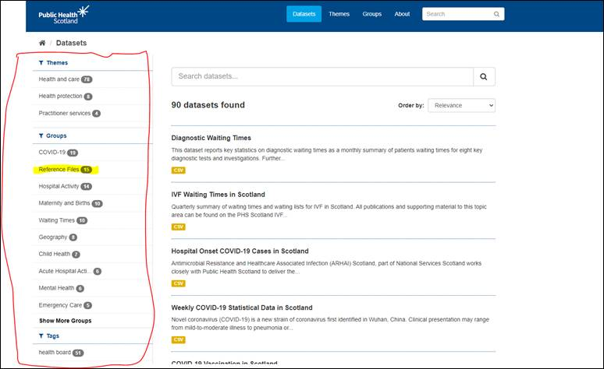

  - The main ones that would be useful for most FOI applicants are Geography codes and Labels and to a lesser extent Hospital Codes.
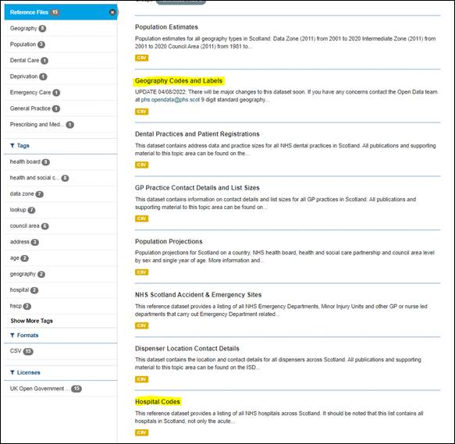

  - In the Geography Codes and Labels, if an applicant is looking to split by health board then the reference file of interest is Health Board 2014 - Health Board 2019 – it lists codes for all territorial boards – NHS Shetland is: S08000026.
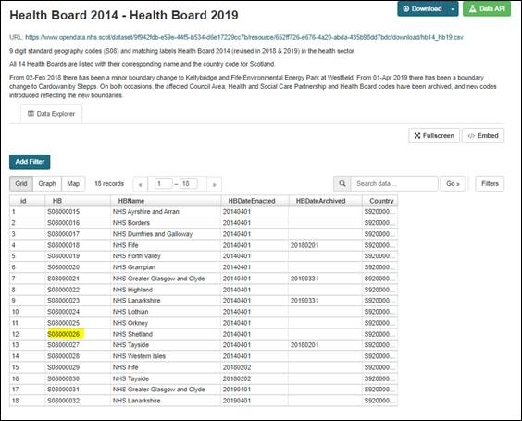

  - With these codes, you can focus on individual boards when exploring regular published data where the data is grouped by board. For example, if someone were interested in reviewing NHS Shetland diagnostic waiting times:
https://www.opendata.nhs.scot/dataset/diagnostic-waiting-times/resource/10dfe6f3-32de-4039-84c2-7e7794a06b31)
they could navigate to above URL, enter the NHS Shetland Health Board code in the Search box and click ‘Go’. This limits the data to just NHS Shetland data:
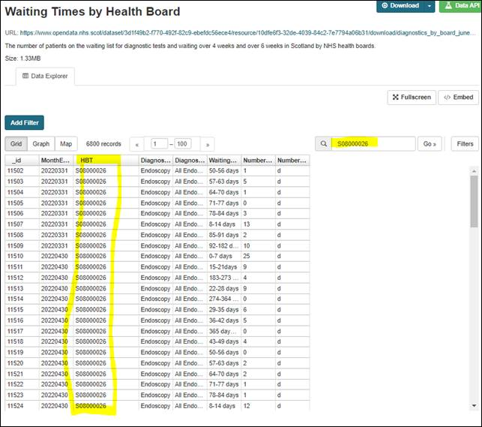

  - Similarly, using the hospital code Z102H would allow someone to filter published data to show only Gilbert Bain Hospital where the dataset in question is grouped at hospital level, e.g. Cancelled Planned Operations:
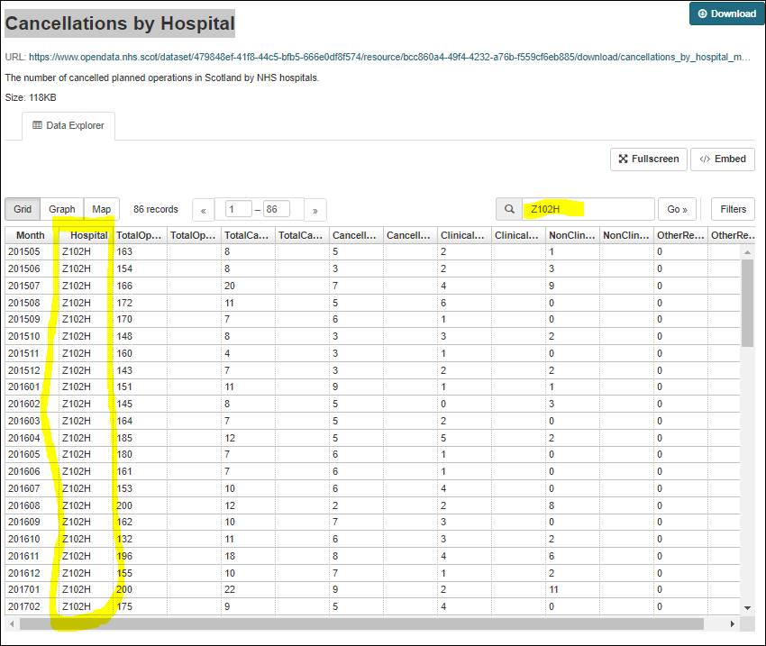

- Groups tab
  - The Groups tab is also available for a more visual grouping of datasets/publications https://www.opendata.nhs.scot/group:
